Assignment - 4 Wireshark Lab : Ethernet and ARP

Name - Atish Kadam
Roll No - CS25MTECH14003
______________________________________________________________________

PART A: Ethernet.
- Question
Ans -
Source MAC Address (48 bits Ethernet address ) - 2c:f0:5d:68:24:c6

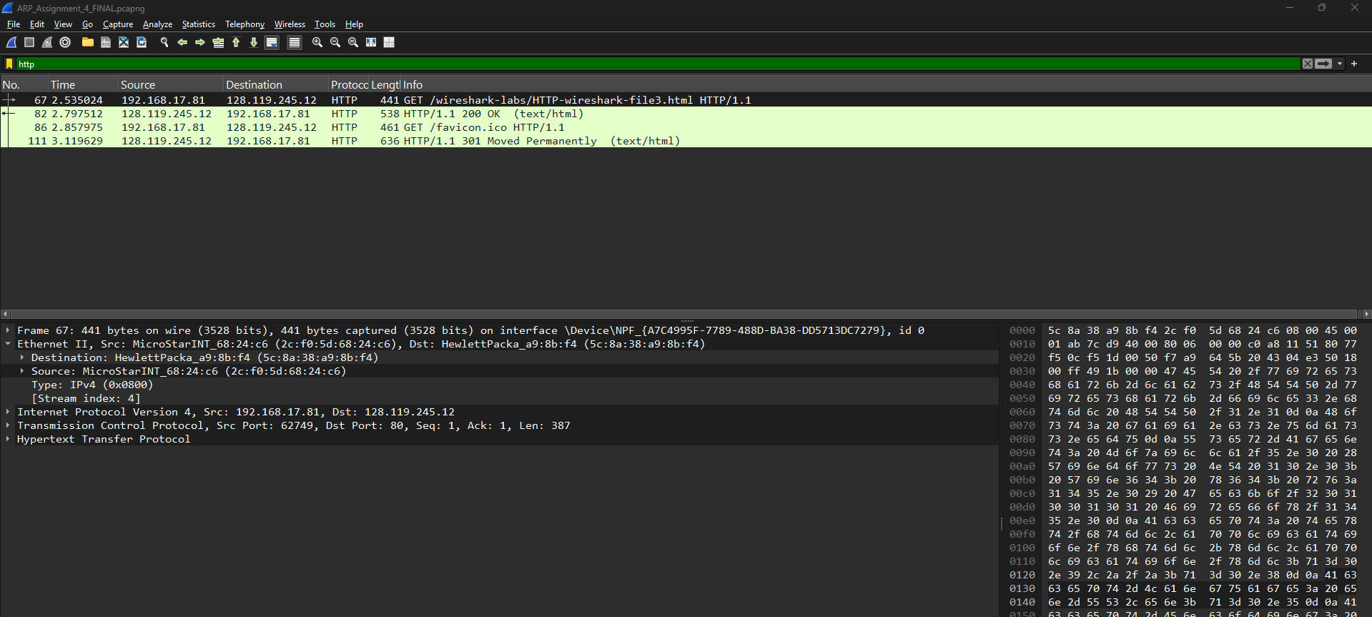

- Question
Ans -

Destination MAC Address (48 bits Ethernet address ) - 5c:8a:38:a9:8b:f4
No,
Ethernet frames work only on the local network (LAN).
As gaia.cs.umass.edu is on a remote network, my computer (Source) sends the frame to the "next hop" responsible for forwarding the packet toward the final destination.
My computer found this MAC address by sending an ARP request for its gateway's IP (128.119.245.12), as seen in Frame 67.

- Question
Ans-
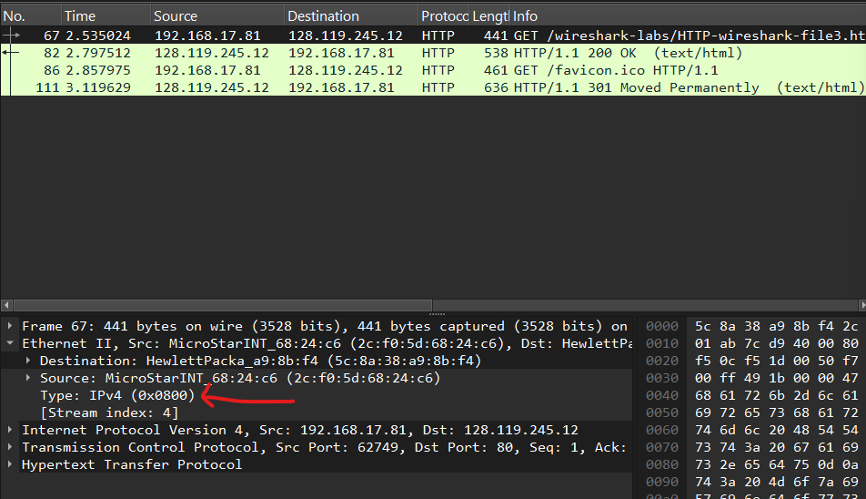
The Hexadecimal value for the 2 Byte frame type field in ethernet frame carrying the HTTP GET request is - IPV4 (0x0800)

- Question
Ans -
For calculating the the no. of Bytes “G” is away from beginning of frame-
Ethernet header: 14 bytes
IP header: 20 bytes
TCP header: 20 bytes
14 + 20 + 20 = 54
→ Therefore we can say that “G” appears at 54 Bytes from the beginning of ethernet frame.

- Question

Ans -
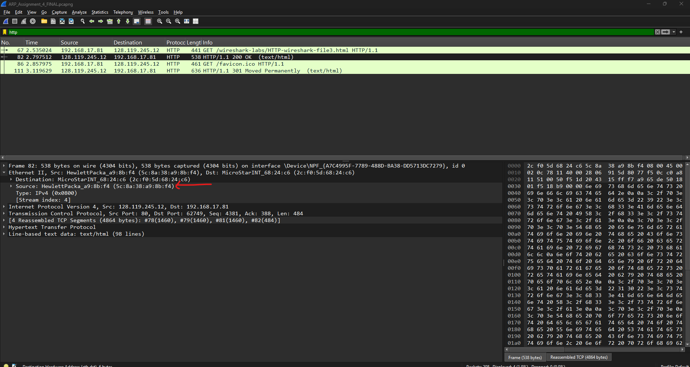
Source MAC Address (Ethernet) = 5c:8a:38:a9:8b:f4
No,
Additionally, neither my computer's MAC address nor gaia.cs.umass.edu's Ethernet source address appears in the HTTP response frame.
This MAC address is associated with my local network's default gateway. Since gaia.cs.umass.edu is on a remote network, no Ethernet frame recorded on my local area network (LAN) can contain its MAC address; Ethernet headers are only used for local delivery. My router receives the HTTP answer from the Internet first. Before sending it to my laptop, the router re-encapsulates the IP packet inside a new Ethernet frame, so the source MAC address in the frame is the router's MAC address.

- Question
Ans -
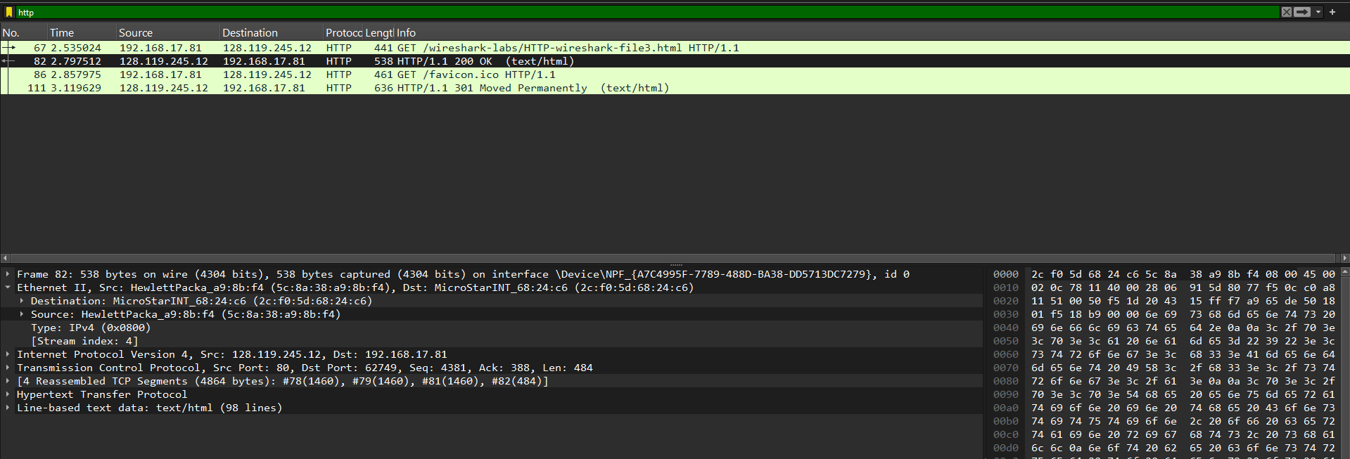
Destination MAC Address (Ethernet) = 2c:f0:5d:68:24:c6

- Question

Ans -
The hexadecimal value for two byte frame type fields is 0x0800.
Upper Layer Protocol is IPV4
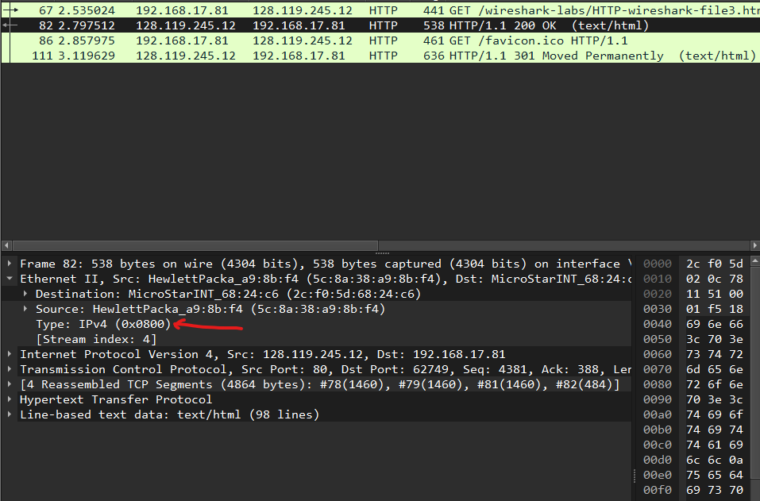

- Question
Ans -
where the ASCII “O” in “OK” appears
Ethernet header = 14 bytes
IPv4 header = 20 bytes (Header Length: 20)
TCP header = 20 bytes (Header Length: 20)
→ total header bytes before payload = 14 + 20 + 20 = 54 bytes
HTTP/1.1 200 OK the “O” of OK is the 14th byte from 1 (index 13 if counting from 0)
Therefore the byte offset from the start of the Ethernet frame is 54 + 13 = 67 bytes, i.e., byte offset 67 (the 68th byte if counting from 1).

- Question
Ans -
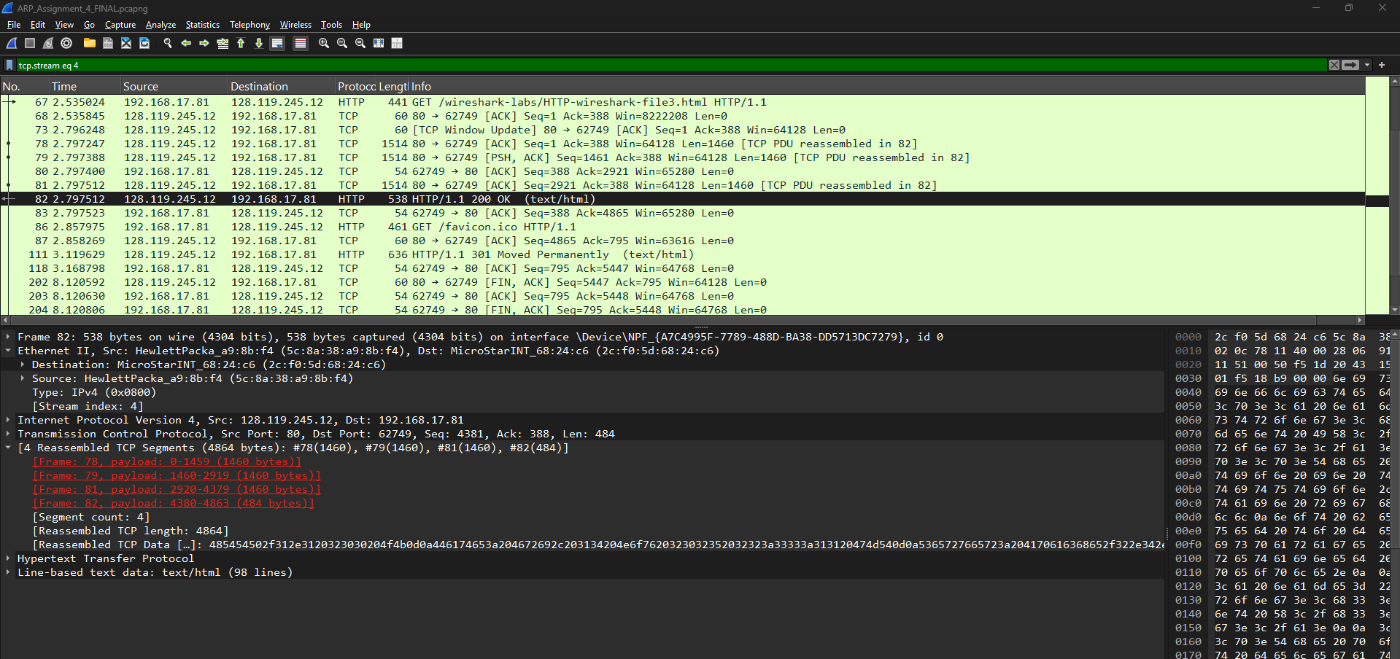
- There are total 4
- The [4 Reassembled TCP Segments] note shows that the complete HTTP response was split across four frames: #78, #79, #81, and #82.
- The complete HTTP reply was delivered across 4 Ethernet frames. The data was split into four TCP segments, which were reassembled by Wireshark from frames #78, #79, #81, and #82.

PART B: ARP.
- Question
Ans -
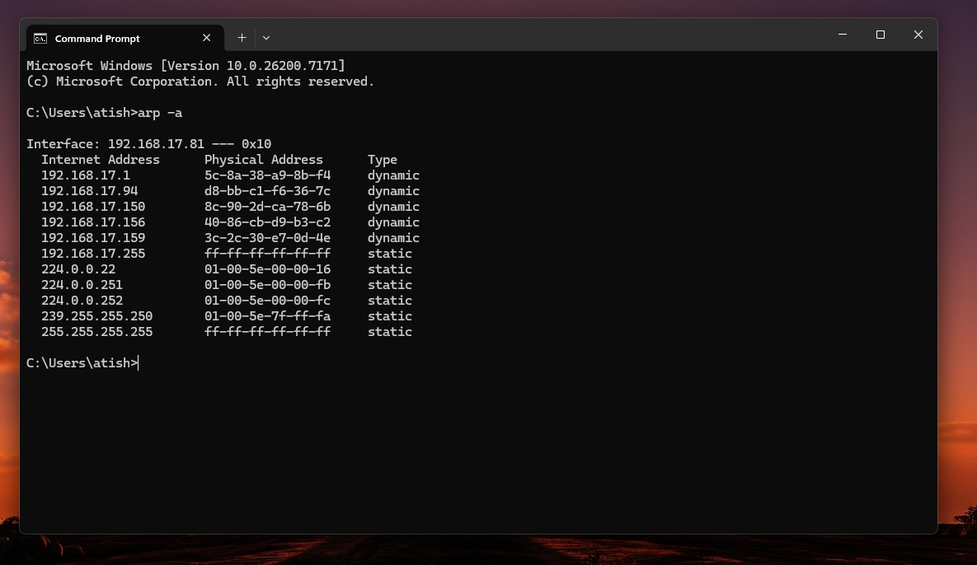
There are total entries 11

- Question
Ans-
Contents - Internet Address - IP Address of
Physical Address - MAC Address
Type - Static or Dynamic

- Question

Ans -
Hexadecimal value of source address : 2c:f0:5d:68:24:c6

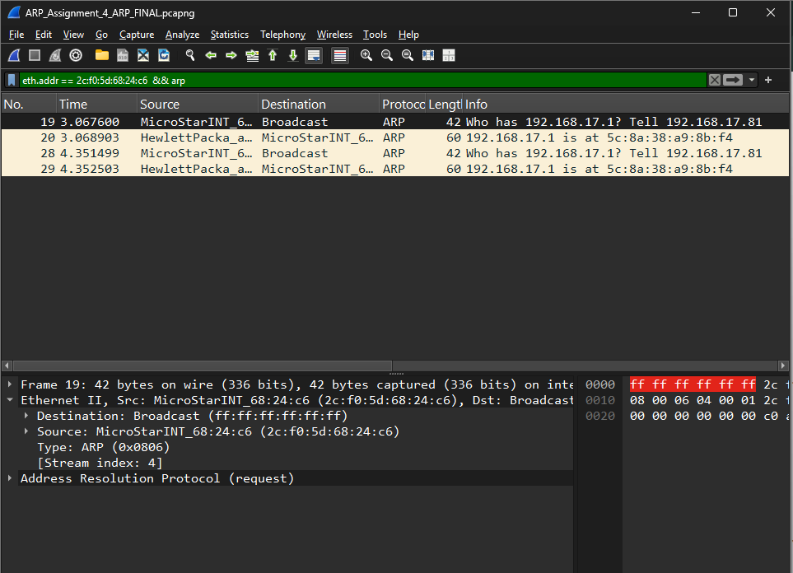

- Question

Ans -
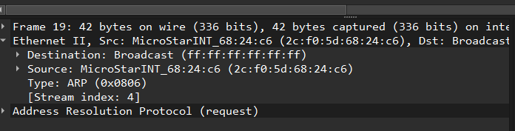

  - Destination address in the Ethernet frame containing ARP Message is : ff:ff:ff:ff:ff:ff
  - The address ff:ff:ff:ff:ff:ff is the Ethernet broadcast address.
  - This address corresponds to all devices on the local LAN, not to a specific client, server, router, or switch.

- Question
Ans -
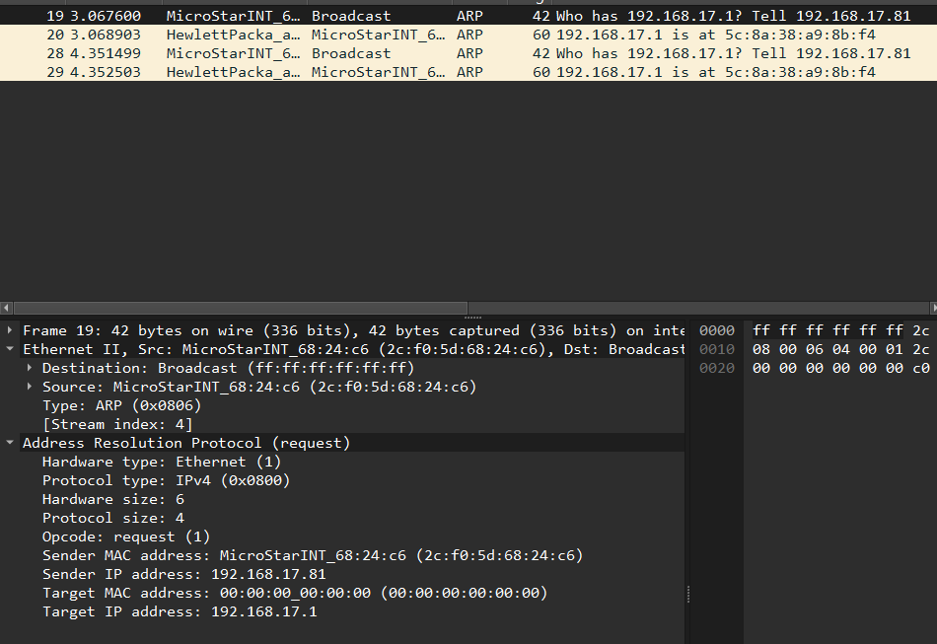
Ethernet Type Field has - Type: ARP (0x0806)
Upper Layer Protocol - ARP — Address Resolution Protocol

- Question
Ans -
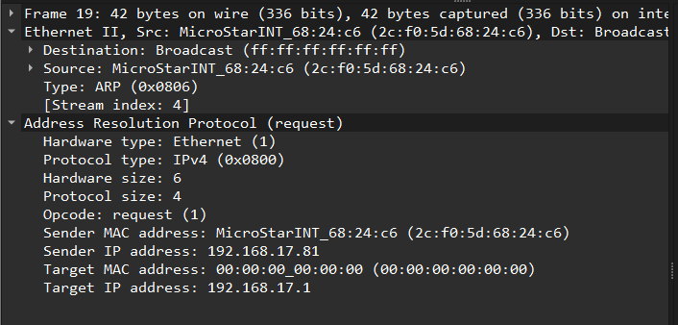
- Ethernet II Header (14 bytes total):
  - Destination MAC: 6 bytes
  - Source MAC: 6 bytes
  - Type (0x0806 for ARP): 2 bytes
- ARP Header (before the opcode):
  - Hardware type (e.g., Ethernet): 2 bytes
  - Protocol type (e.g., IPv4): 2 bytes
  - Hardware size (e.g., 6): 1 byte
  - Protocol size (e.g., 4): 1 byte
Adding those together (6 + 6 + 2 + 2 + 2 + 1 + 1) gives 20 bytes.
The opcode field starts immediately after.

- Question
Ans -
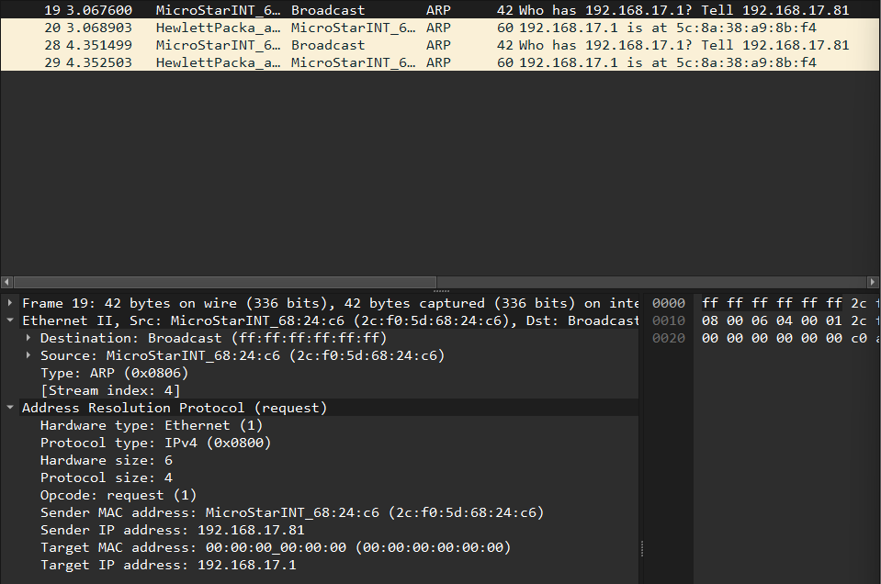
"Address Resolution Protocol" section of your trace: Opcode: request (1)

- Question
Ans -
Yes, the ARP request message contains the IP address of the sender.
Sender IP Address : 192.168.17.81

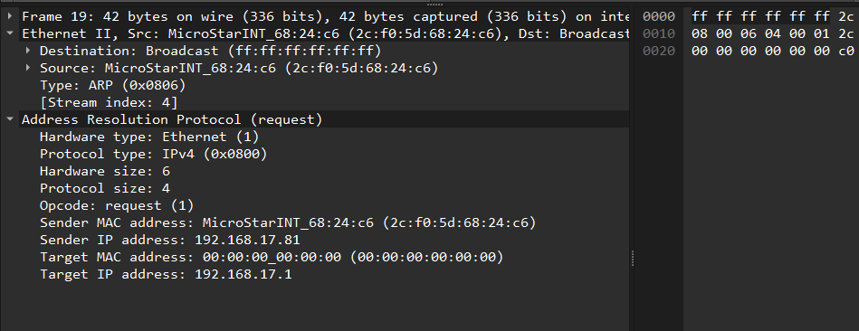

- Question
Ans -
- The IP address of the device whose corresponding Ethernet address being requested is 192.168.17.1.
- This information is found in the Target IP address field within the "Address Resolution Protocol" section of the ARP request packet:
- Target IP address: 192.168.17.1


- Question
Ans -

Opcode: reply (2) — 0x0002 (ARP Reply).
I am the owner of that IP address. Here is my MAC address.

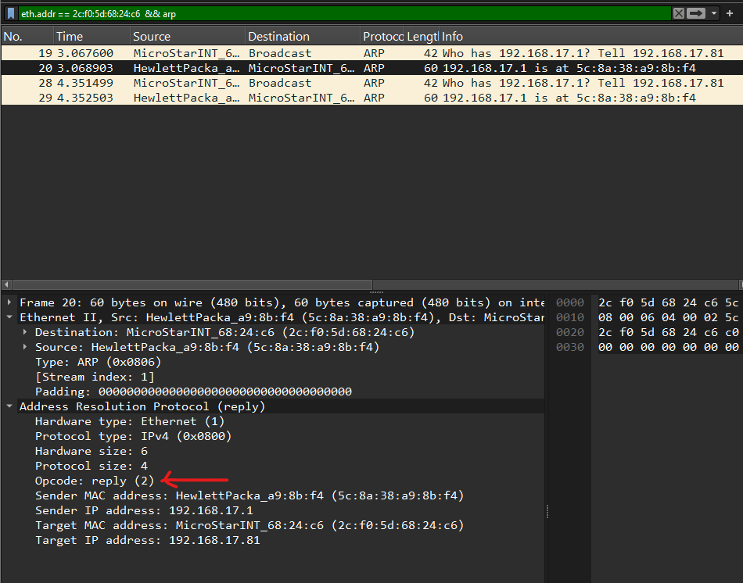

- Question

Ans -

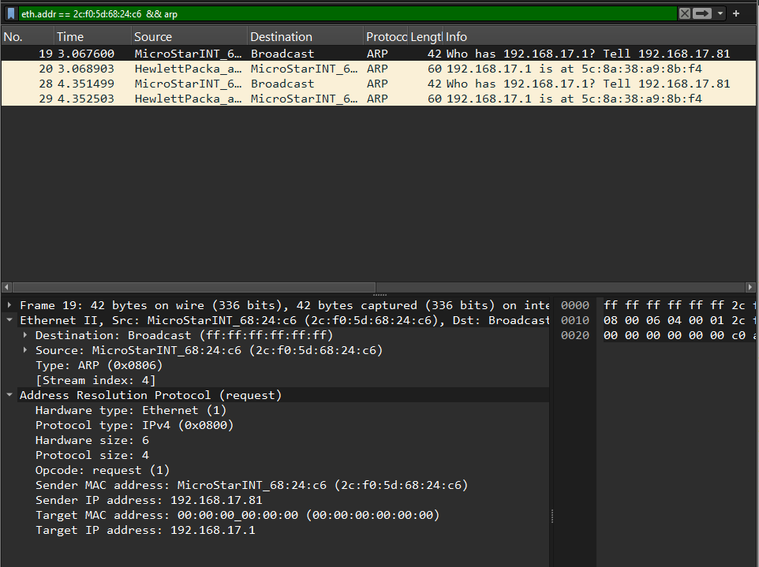

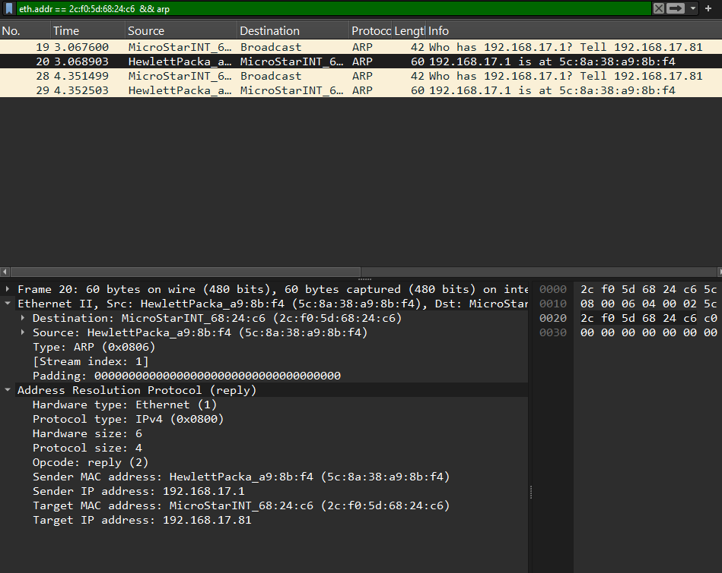

The ARP request (Frame 19) asked for Target IP = 192.168.17.1.
The ARP reply (Frame 20) gives the mapping: IP: 192.168.17.1
MAC: 5c:8a:38:a9:8b:f4
The Ethernet address for 192.168.17.1 is 5c:8a:38:a9:8b:f4.

- Question
Ans -
Other Devices in network sending ARP request messages to same

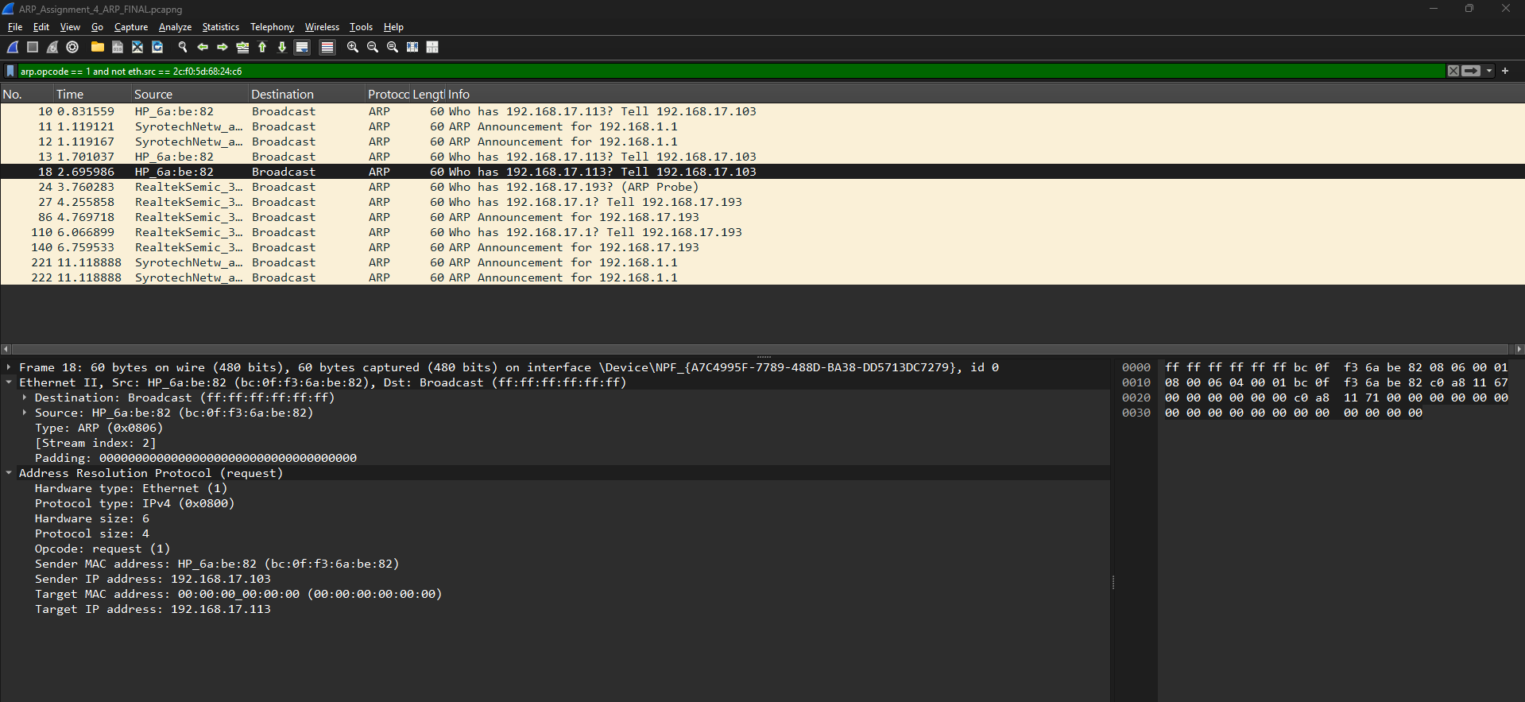

ARP reply message sent in response (We didn’t get any other reply )

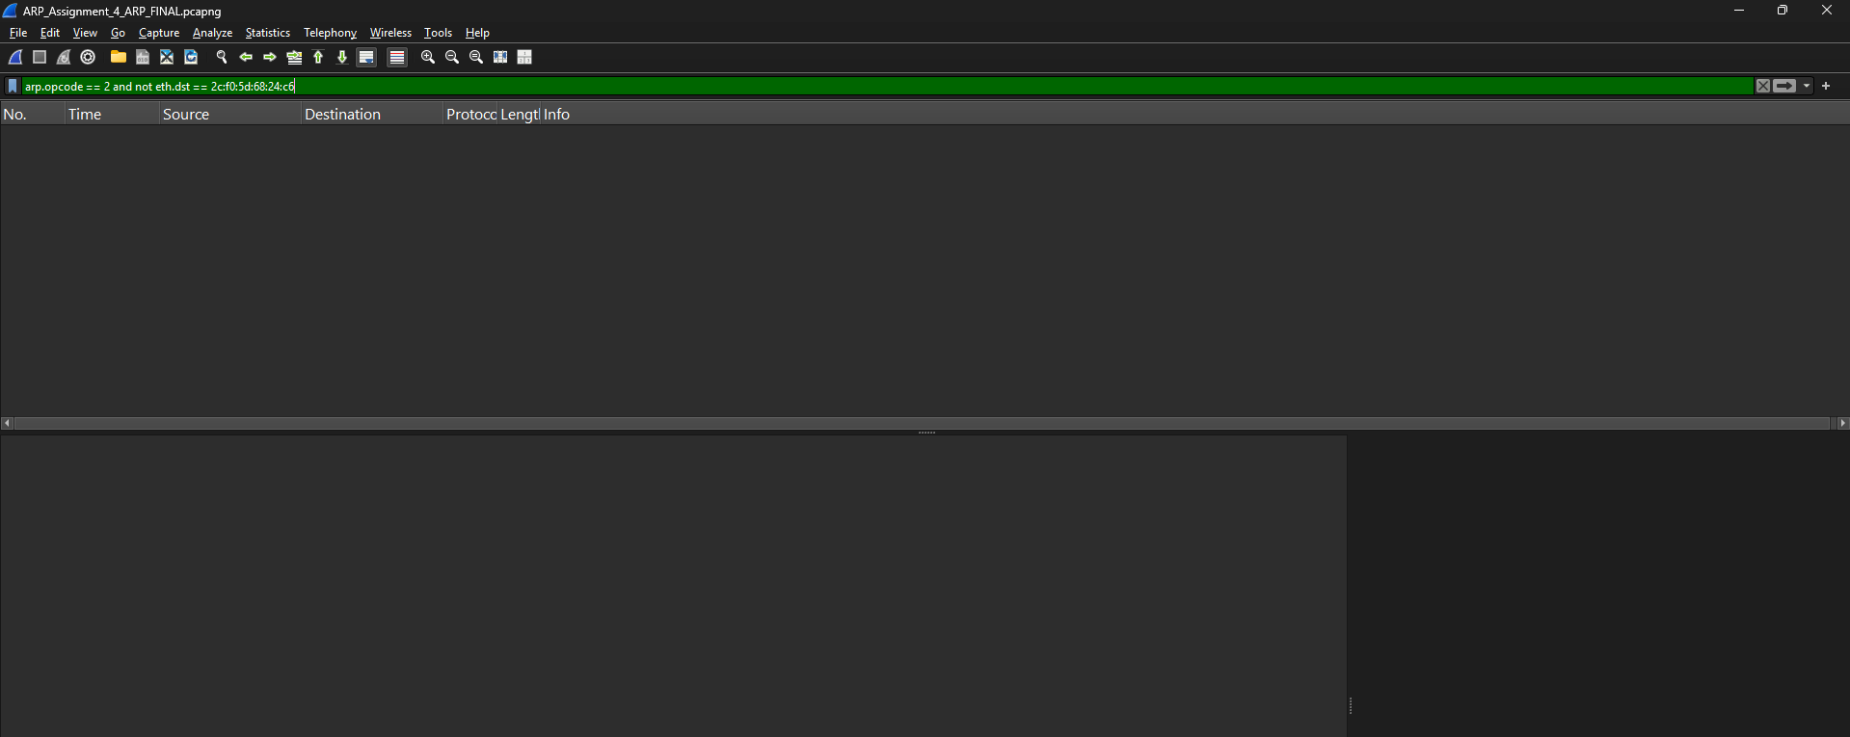

- ARP requests are broadcast and therefore visible to everyone on the local link (so they appear in your capture).
- ARP replies are unicast and a switch forwards unicast frames only to the requester’s port.
- As our machine was not the requester for those other ARP requests, those replies were sent directly to the requesters and my NIC did not see them.
- Therefore replies to other hosts’ ARP requests typically do not appear in our trace unless the switch is configured to mirror traffic or the capture was taken on the requester.
Please Find attached PCAP File
Assignment_4

